Abstract. The basic architecture of a Question Answering System (QAs), based on Natural Language Processing, subsumes question analysis and answer extraction. The system is based on semantic analysis, relates the words logically and provides an admissible answer to the user query. Instead of using template based query, it accepts questions phrased in various forms.

- Introduction
With the rapidly growing data, information retrieval has become a challenge. In QAs, user poses the query in natural language and the system finds the most precise and concise answer for it from the given corpus. The QAs can be of two types: Open Domain Systems and Closed Domain Systems. The former are those that can answer the query asked related to any domain while the latter work on restricted domain. Examples of the latter type are Medical, Child Care, Weather Forecasting, etc. This paper deals with open domain system. In general, Open Domain Systems have lower accuracy because the vocabulary is unlimited and a particular word usually comes in more than one sense.
In general, QAs give more precise answers compared to the general search engines because the queries can be formulated more precisely. For example, a user may need to know who the President of India was in 1976. The keyword based search engines will only permit the user to frame the query in terms of keywords like “President”, “India”, “1976”. They will retrieve all documents that have these keywords and rank them using some technique like the page ranking algorithm. The precision of such a system is likely to be low because most of the retrieved pages will not contain the information that the user needs. On the other hand, the QAs will accept the entire query, infer the actual need of the user, find the documents that may contain the answer and then identify the sections that contain the precise answer within each such document.
Extensive research has already been done in this field. Various approaches used for question answering system are keyword matching, rule based matching, semantic web, ontology, template based. The previous research done on this problem has resulted in systems like FREyA (Damljanovic et al., 2010)^{[8]}, ORAKEL (Cimiano et al., 2007)^{[7]}, SWSE (Andreas Harth., 2007)^{[1]} .
SWSE (Andreas Harth., 2007)^{[1]} though is a web based system it has not worked on question analysis. Thus questions phrased in complex form do not return the correct answer. Also there is RDF generation but searching is only based on keywords. FREyA (Damljanovic et al., 2010)^{[8]} a Feedback Refinement and Extended Vocabulary Aggregation system uses syntactic parsing. In FREyA, ontology is applied on user query with the help of the user's feedback. Although the Precision and Recall value for the tested data reaches a high of 92.4% it asks user each time for suggestion. Also it missed certain entries while matching by fuzzy logic. ORAKEL (Cimiano et al., 2007)^{[7]} based on knowledge represented in natural language mapped on ontology structures, handles only wh-based questions. For efficient mapping, lexicon needs to be updated constantly. The system fails straight away for a grammatically incorrect input.

In contrast to the earlier approaches, the current system is able to analyze the question in order to infer the actual need of the user. This is difficult since the same question may be framed in many different ways. Obviously, Natural Language Processing is required at this stage. The result of the question analysis would be that the question is reduced to some cardinal form that represents the information needs of the user. At the second level, the answer searching system has to sift through the corpus and retrieve the correct sections of the relevant documents. Once again, since the actual answer can be written in various forms, so the search for the correct answer also requires Natural Language Processing.
The question analyzer of this module, unlike other previously developed systems, works on the question in a semantic way, no matter how complex its phrasing is. Also the same question framed in different ways, would return the same cardinal form. Instead of simply using a template based approach for question analysis, it understands the relation between the words i.e. their dependencies ^{[4]} and returns the expected answer type.
The QAs presented in this paper forms a state chart graph of the relevant documents in the corpus. These graphs also include cause-effect relationships. These graphs can potentially span an entire document. Thus, sentences that are physically far apart but related directly or indirectly by some common entity will acquire direct edges in the graph. The search for the answer reduces to a traversal of the graph, as per the question. For returning the answer it uses a heuristic approach and searches according to the expected answer type. This approach efficiently deals with both factoid as well as non-factoid type of questions and is immune to common insignificant grammatical errors.
In the rest of the paper we have explained the working and design of our system. The next section contains the methodology. The basic two modules of the system : the question analysis and answer extraction, are explained. Semantic analysis of questions is done and rules are formulated from the dependency tree^{[6]}. The question Analyzer thus categorizes the type of answer expected. For Answer Retrieval, paragraphs are ranked using biased entity-verb matching. A State Chart graph, including cause effect relationships, is generated and answer is searched by a heuristic based approach. The later section contains the result of the evaluation done on TREC-8 test set.

Methodology

2.1 Architecture
The architecture of the system is given in Figure 1 below showing the major modules and the interconnections between the modules.
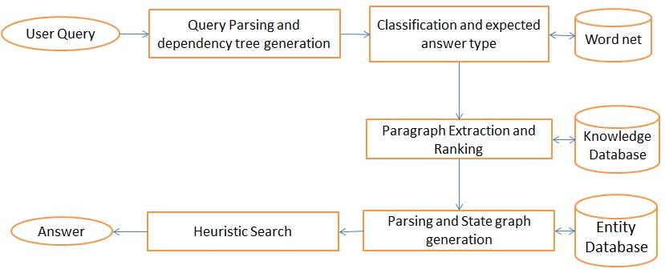
Figure 1 : Architecture of the system

2.2 Preparing Corpus and Lexical Database
The corpus data is prepared in .txt file or a set of files. The user at any time may add/delete/modify the files and the system will automatically search on the updated corpus. The corpus is tagged by Stanford NER^{[10]}. The answer analyzer uses the corpus to search for the answer. A lexical database is created which is referred for classification of entities during question and corpus analysis(in graph generation to assign “descriptor ”to the various nodes).
Example:
Descriptor | Entity
Animal | Cat, Dog, Lion
Location | Europe, Switzerland, Germany
Time | Morning, June, A.M. , Sunday
Number | Rupees, Litre, Mile
Organization | Microsoft, ACM, UNO
Language | Hindi, English, Spanish

2.3 Question Analysis
2.3.1 User query
There is a simple interface allowing the user to enter the question in natural language.

2.3.2 Query Parsing
The query fired by the user is parsed using the Stanford Parser^{[11]} and the dependencies are processed to return the “classifier” word as shown in Fig 2. The hypernym (from word net) of the classifier word is used to get the type of answer expected. The question analysis algorithm classifies the expected answer type into person, location, time, number, organization and miscellaneous entities.
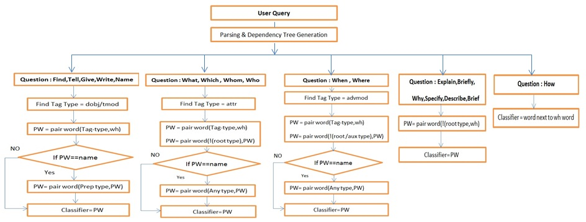
Figure 2

2.3.3 Classification and expected answer type
The same question may be phrased in different ways, yet this module must return the same expected answer type. For example, given the question samples below, we will get “Location” as the expected answer type.
Question 1: What is the name of the place where Gandhi was born?

Dependency table:

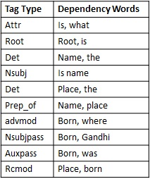

Pair word(x, y) returns the word paired with tag type x and word y.
For what type question:
wh= ”what”
tag_type=attr
PW=pair word (attr, tag type) =is
PW=pair word (! root type, is) =name
Since PW= =name
PW=pair word (any type, PW)= place
(While reading the data from dependency table, we always consider only the data that is below the previously accessed data of the table, therefore, in the above step we chose [prep_of, name, place] and not [Det,Name,the])

Classifier=place
Type of answer expected (as derived from hypernym of place from word net) = location

Question 2: Where was Mahatma Gandhi born?

Dependency table:

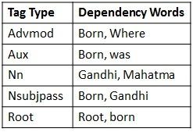

Pair word(x, y) returns the word paired with tag type x and word y.
For what type question:
wh= ”where”
tag_type= Advmod
PW=pair word (tag type,wh) =Born
PW=pair word (! (root type|Aux type), PW) =Gandhi
Since PW! =name

Classifier=Gandhi
Type of answer expected (as derived from wh-word given in question(“where”) =location

Question 3: Tell the birth place of Mahatma Gandhi?

Dependency table:

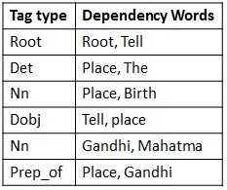

Pair word(x, y) returns the word paired with tag type x and word y.
For what type question:
wh = “Tell”
tag_type= Dobj
PW=pair word (tag type,wh) =place
Since PW! =name

Classifier=place
Type of answer expected (as derived from hypernym of place from word net) =location

The above modules complete the question analysis part. Once we have inferred what is expected by the user, we can now find the precise sections in the corpus that contain the answer to the user’s question.

2.4 Answer Analysis

2.4.1 Paragraph Ranking
Nouns and verbs are the primary key words of the query. The vital nouns and verbs of the questions are extracted (i.e. Verbs like was, did etc. or other common verbs or helping verbs are ignored if they are not the only verb of the question), and all paragraphs that contain the same nouns and verbs as the question are ranked. The paragraphs of the corpus having the nouns and verbs of question occurring in the same sentence of are given more preference. This way each paragraph is given a score. This considerably reduces the overall text to be searched.

2.4.2 State Chart Graph Generation
The ranked paragraphs are parsed using the Stanford Parser^{[11]}. The paragraph with the best score is taken and parsed. Rules have been formulated to generate graph out of the parsed paragraph.

2.4.2.1 Representing a Sentence in a graph:
The system goes through the parsed sentence and generates the graph.
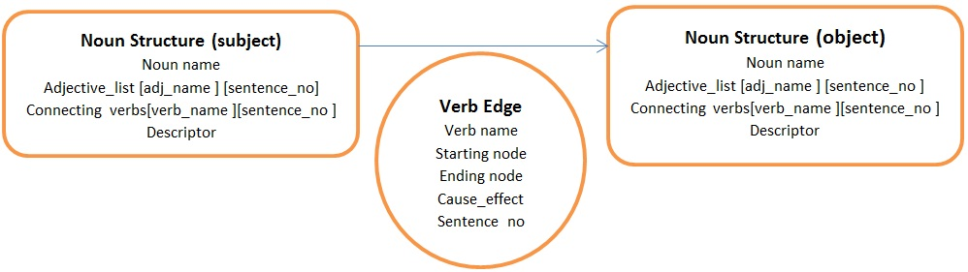

2.4.2.2 Rules for Graph Generation:
- Proper Noun followed by Proper Noun is Merged into a single node
- Adjectives become characteristic of noun following it.
- If a verb is followed by several nouns in continuation separated by comma or conjunctions then same verb edge from previous noun to all.
- If more than one verb is present then there are multiple edges between two nodes
- If the same node is present as both subject and object noun for a verb, then there is no need to make that transition.
- If there is a cause effect relationship between two nodes then it is represented by temporal edge ‘ci’ for cause numbered i and ‘ei’ for effect numbered i.
- Make all cardinal numbers as noun nodes.
- Sentences with no object noun have their subject connected to a Sink node by the verb.

Example, Paragraph:
Mahatma Gandhi was born in the house of a senior government official Karamchand Gandhi. Karamchand Gandhi was married to Putlibai. Putlibai raised Mahatma Gandhi in coastal Gujarat. Mahatma Gandhi sought to practice nonviolence and truth. Mahatma Gandhi was trained in law in London. Mahatma Gandhi was too shy to speak up in court. Therefore Mahatma Gandhi attempts at establishing a law practice failed. Mahatma Gandhi faught and rebelled against White men.

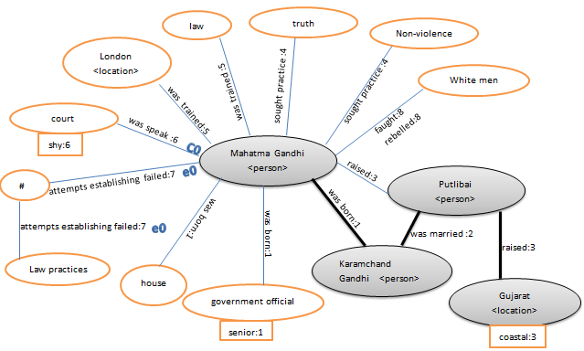

2.4.3 Graph Searching
Expected answer type is searched in the graph in a direction of the verb of the question starting from the nouns of the question using heuristic approach. The verb table is scanned and the sentence numbers having the same verbs as the question are marked.
Let,
a[ ] = {sentence numbers having verbs of question}
A visited list is maintained of all the nodes that can be visited from the processed nodes. Initially this list has only the noun nodes of the question. From this list, the “best” node is selected to be processed, and is popped out. Its direct neighbors are added to the visited list. Nodes that are processed cannot be visited again.

b[ ] = {sentence numbers of the verbs that led to the nodes of visited list}
The heuristic function h(s) for directing the search is calculated as:
h(s) = min(c (i), for ¥ i € b)
Where c(i) = min (|a[j] - b[i]| for ¥ j € a)
This way the most appropriate verb edge is selected, and the node at the other end of it is “processed”. The expected answer type is looked for in the “processed” node. This continues till the expected answer is found. The following example will make the process clear.
For the above example:
Expected answer type: location
a(array of sentences having “born”)={1}

Start from question node: visited= {Mahatma Gandhi}
b= {1}
c={0}
h(s) =min(c)=0, along sentence no.1
Node Processed= {Mahatma Gandhi} == “question node”, hence cannot be expected answer
Now,
Visited= {house, government official, Karamchand Gandhi, Putlibai, non-violence, truth, law, London, Court, #, White men}
b={1,1,1,3,4,4,5,5,6,7,8}
c={0,0,0,2,3,3,4,4,5,6,7}
h(s) =min(c)=0, along sentence no.1
Node processed={house}!=location
Now,
Visited= {government official, Karamchand Gandhi, Putlibai, non-violence, truth , law, London, Court, #, White men}
b={1,1,3,4,4,5,5,6,7,8}
c={0,0,2,3,3,4,4,5,6,7}
h(s) =0
Node processed= {government official}! = location
Now,
Visited= {Karamchand Gandhi, Putlibai, non-violence, truth , law, London, Court, #, White men}
b= {1,3,4,4,5,5,6,7,8}
c={0,2,3,3,4,4,5,6,7}
h(s)=0
Node processed= {Karamchand Gandhi} != location
Now,
Visited= {Putlibai, non-violence, truth, law, London, Court, #, White men}
b={3,4,4,5,5,6,7,8}
c={2,3,3,4,4,5,6,7}
h(s) =2
Node processed = {Putlibai}
Now,
Visited={Gujrat, non-violence, truth , law, London, Court, #, White men}
b={3,4,4,5,5,6,7,8}
c={2,3,3,4,4,5,6,7}
h(s)=2
Node Processed={Gujarat} == location
Expected answer type found.
Return the sentence from the text corpus containing the expected answer.

2.4.4 For cause effect relationships: (“Why” type of question)
A node is selected such that its noun name matches with the noun of the question and it is also connected directly to the verb of the question. The closest effect node to it is selected (ei). Now the cause of that effect (ci) is selected. If this cause is also marked as the effect of some other cause, the cause leading to it is selected, till all the causes leading to the final event are selected. This way even the cause-effects, that are related, but are sentences apart are considered. The transitive relationships of cause effects are also considered.
E.g. a causes b; b causes c; c causes d; d causes e.
The question what causes e will give answer: abcd

2.4.5 Answer
Most appropriate nominee answer is returned as output in natural language. If not satisfactory, the user can always ask for the next appropriate one.

- Evaluation
The evaluation has been performed on the TREC 2008 Dataset. The dataset contains about 1000 documents with 400 questions. The correct answer to each of the questions is known. Therefore, this dataset is used as a benchmark to test the proposed approach. The accuracy of the proposed method is judged using the Mean Reciprocal Ranking (MRR) as described below.

Mean Reciprocal Ranking
The accuracy is calculated by considering the first n answers for every question, where the values of n taken into account are like 1, 5, 10 and 30. The MRR of answer correctly answered is calculated by the following expression:

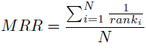

Where N is the number of questions and rank_{i} is the rank of the correct answer for the i−thquestion. If the question is not correctly answered in n attempts, then the reciprocal, 1/rank_{i}, is equal to 0. In the ideal case, the MRR should be equal to 1 i.e. all the questions are correctly answered by the top ranked answer. The worst case is when MRR is equal to zero i.e. the system could not find the correct answer to any of the questions in the top n results.

In Table 1 below we present the results obtained by the proposed method when n = 5. As we can see, 108 questions were correctly answered by the top ranked result resulting in a total score of 108 for MRR. Similarly, 146 questions were correctly answered by the second ranked response resulting in a contribution of 73 to MRR. There were 24 questions whose answer could not be found in the top five results. The overall MRR was 0.5486.

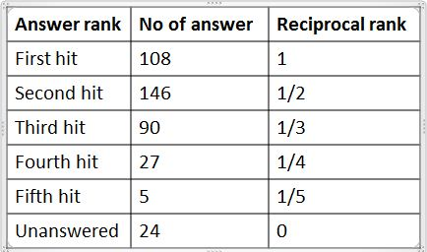
Table 1: Results with n = 5.
It may be noted that if we increase the value of n then the MRR value will rise. This is because we will get a small, positive contribution from the last 24 questions whose correct answer could not be found in the top 5 results. The contributions of the other questions will not change by changing the value of n.

First Hit Success (FHS)
Another metric used for accuracy evaluation is considered by taking only the first answer for every question for the N questions fired. It is used where users solely depend on the system for finding the answer. If the first answer retrieved is correct, the FHS is 1 else it is 0. For the proposed work the FHS percentage = 27 %.

The Microsoft Research question-answering system based on combination of Okapi retrieval engine, Microsoft’s natural language processing system (NLPWin), and a module for matching logical forms was evaluated on TREC-8 test set and had a performance efficiency of .446(MRR)^{[9]}. Our system on the other hand has an efficiency of .5486 (MRR).

Conclusion
We presented a novel approach for extracting answer to a question from a corpus data. Our system works with an efficiency of .5486 (MRR value). The question analyzer gives the same answer even when the same question is re-phrased in complex forms. Also the answer analyzer extracts answer distributed across various sentences, not necessarily occurring together in the paragraph or directly stated in the text.

Acknowledgement
This research paper is supported by Prof.Sudeep Sanyal, IIIT Allahabad. Without his guidance the paper wouldn’t have been possible.

- References
[1] Andreas Harth, Aidan Hogan, Jurgen Umbrich, Stefan Decker: Searching and Browsing Linked Data with SWSE: http://sw.deri.org/2007/02/swsepaper/paper.pdf

[2] Doan-Nguyen Hai, Leila Kosseim, "The Problem of Precision in Restricted-Domain Question Answering. Some Proposed Methods of Improvement", In Proceedings of the ACL 2004 Workshop on Question Answering in Restricted Domains, Barcelona, Spain, Publisher of Association for Computational Linguistics, July (2004) PP.8-15. http://acl.ldc.upenn.edu/W/W04/W04-0503.pdf

[3] Green, W.Chomky, C.Laugherty, K.BASEBALL: "An automatic question answer". Proceeding of the Western Joint Computer Conference (1961), PP. 219-224. http://www.stanford.edu/class/linguist289/p219-green.pdf

[4] Adam Lally, Paul Fodor: "Natural Language Processing With Prolog in the IBM Watson System", IBM Thomas J. Watson Research Center. March 31, 2011.http://www.cs.nmsu.edu/ALP/wp-content/uploads/2011/03/PrologAndWatson1.pdf

[5] Rivindu Perera, Udayangi Perer: "IPedagogy: Question answering system based on web information clustering", 2012 http://www.iit.ac.lk/academic/37-research/512-ipedagogy-question-answering-system-based-on-web-information-clustering.html

[6] Vasin Punyakanok, Dan Roth, Wen-tau Yih, “Natural Language Inference via Dependency Tree Mapping: An Application to Question Answering”, Department of Computer Science, University of Illinois at Urbana-Champaign, November 9 Volume 6.https://www.ideals.illinois.edu/handle/2142/11100

[7] Philipp Cimiano, Peter Haase, Jorg Heizmann. “Porting Natural Language Interfaces between Domains: an Experimental User Study with the ORAKEL System”. In IUI '07: Proceedings of the 12th international conference on intelligent user interfaces, pages 180|189, New York, NY, USA, 2007. ACM.ISBN 1-59593-481-2.doi:
http://doi.acm.org/10.1145/1216295.1216330.

[8] D. Damljanovic, M. Agatonovic, H. Cunningham: “FREyA: an Interactive Way of Querying Linked Data using Natural Language”. In: Proceedings of 1st Workshop on Question Answering over Linked Data (QALD-1), collocated with the 8th Extended Semantic Web Conference (ESWC'11).Heraklion, Greece, June 2011. http://gate.ac.uk/sale/dd/experiments/qald/paper-final.pdf

[9] David Elworthy: Microsoft Research Limited, St. George House, 1 Guildhall Street, Cambridge CB2 3NH, UK http://trec.nist.gov/pubs/trec9/papers/msrc-qa.pdf

[10] Stanford Named Entity Recognition (NER) http://www-nlp.stanford.edu/ner/

[11] Stanford Parser http://nlp.stanford.edu/software/lex-parser.shtml

